1. Delete the fields in RED box

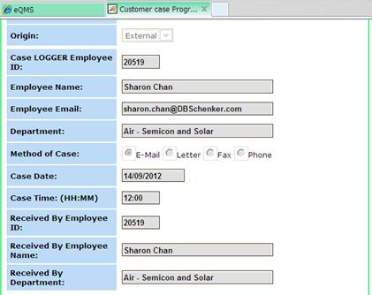

2) Change “Customer Refno” to “Customer contact no”

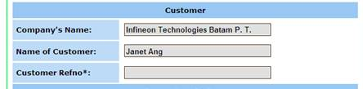

3) Add “if applicable”  under :Reason for rejection”

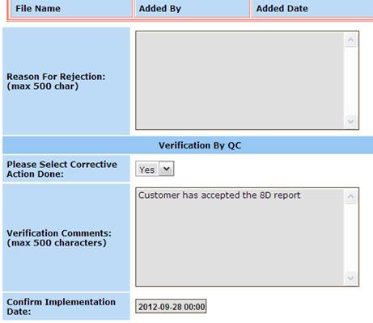

4) If there is a blank entry or “SPACE BAR” entry by user, prompt user to enter (\* please provide required information. Enter Nil and NA as appropriate”) else they cannot save and complete their submission.

5) Reword “QC” to Quality for the entire CCMS. Eg.

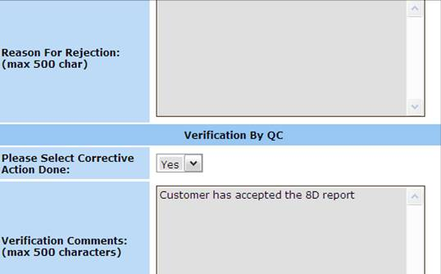

6)  If “ EXTERNAL”  is selected, there shall be a column “Attach Customer’s acceptance” after root cause and solution before QC verification.

Also if they do not attach any information they system will not allow them to proceed the next action.

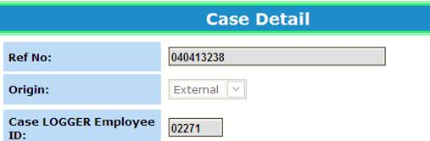

Incude before Verification by QC fieldInclude ATT.  FIELD Attach Customer’s acceptance